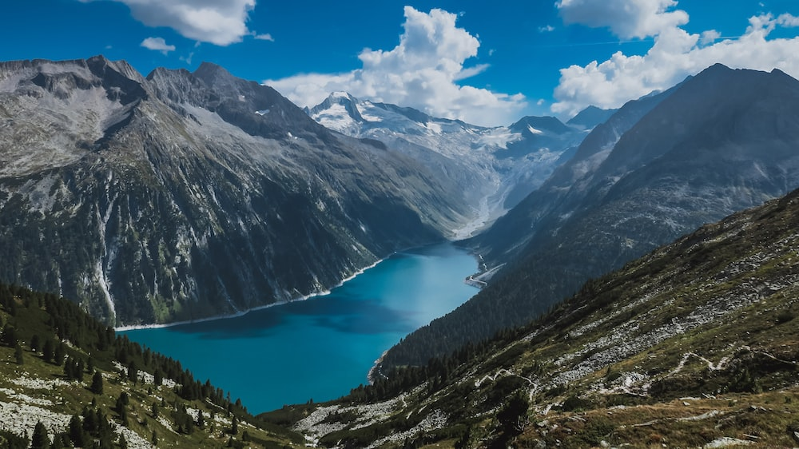

Moles, Squirrels and Badgers

Summer Term 2025

***Raging Rivers and Majestic Mountains***

**English**Our class text for the summer term will be The Firework Maker’s Daughter. It tells the story of a young girl called Lila who wants to become a firework-maker, like her father Lalchand. She journeys to get Royal Sulphur from Razvani the Fire-Fiend at Mount Merapi, as all aspiring firework-makers must do.

Reading for pleasure and enjoyment will lie at the heart of our English curriculum. Our new, class reading corners have become a big hit with our children. The children will be involved in guided reading, using a wide range of texts, linked to our topic. They will take part in group discussions and will be encouraged to share their own views and reading interests. Through discussion and questioning comprehension skills will be developed, enabling children to increase understanding and appreciation of literature.

Children will have the opportunity to find out more about a new poetry style this term. In their writing, they will be progressing their skills by writing explanation texts and studying a chosen author in more depth.

Opportunities within all areas of the curriculum will be made available for children to develop their spoken language through discussion, drama, and presentations.

**Science**In Science this term, we will be initially looking at ‘Sound’. We will be learning about how sound travels as well as investigating volume and pitch. In the second half-term, we will move onto to looking at animals including humans. The children will construct and interpret a variety of food chains, identifying producers, predators, and prey.

**Our topic…**

Our main topic for Summer term will be Raging Rivers and Majestic Mountains.

We will be learning about what mountains and rivers are, as well as looking further into the Earth’s physical processes of how they are formed. Children will develop their geographical skills further by locating rivers and mountains around the world using a variety of maps and atlases. By the end of this unit, the children will know how rivers shape the land e.g. erosion, transportation, deposition, meanders, and ox-bow lakes.

In addition to this, children will be introduced to the Water Cycle and apply this to their knowledge of mountains and rivers.

Children will deepen their understanding of human geography by looking at how rivers and mountains are used by humans e.g. settlements, land use, and trade. We will also look at flooding and how this is affects humans as well as the landscape and environment.

This is an incredibly fascinating topic, and we aim to make it a memorable one! Through cross-curricular learning we will partake in some exciting activities. Make sure you continue to keep an eye on our web pages to see the fantastic learning taking place!

**Maths**Maths will be taught as an individual subject and will continue to adhere to the curriculum objectives. Teaching will enable children to become fluent in arithmetic as well as being able to reason and problem solve. Our Maths lessons in the Spring term will focus Length, Perimeter & Area and Time in the first half-term, before moving on to Shape, Volume & Capacity (Yr3), Co-ordinates (Yr4) and finally Statistics. Pupils will be extended at every opportunity to ensure their potential as mathematicians is achieved. Year 4 children will be focusing on preparing for the statutory Multiplication Check which will take place in June.

**Take home task to support work in school**To prepare for our new topic, it would be brilliant if the children could find some fascinating facts about rivers or mountains. This could be research about how mountains and rivers are formed or facts about famous mountains and rivers around the world. These can be presented in a medium of their choice – a model would be especially good! They will need to be prepared to present and talk about their work to the rest of the class.