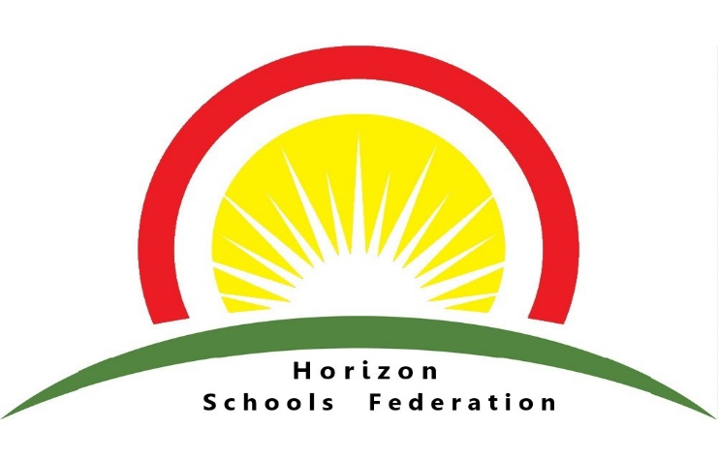

CLASS TEACHER - Permanent Post - Full Time MPS

Required: September 2025

Number on Roll: 258

An exciting opportunity has arisen to join our teaching team at Donington Cowley Endowed Primary School part of the Horizon Schools Federation.

We are looking for an enthusiastic, dynamic class teacher with a passion for learning, who can demonstrate excellence and enthusiasm within their practice and uphold our school vision and values. The position will initially be for Key Stage 1 or Lower Key Stage 2, depending upon the successful candidate’s experience.

Applications from ECTs are welcome and we pride ourselves of providing excellent support and professional development opportunities for teachers in their early careers. An experienced and dedicated school-based mentor will be allocated and opportunities to work with leaders across our federation are prioritised to ensure effective sharing of expertise.

Our federation offers a welcoming environment where everyone is respected and listened to; a school where we take pride in ourselves and our achievements, enabling children to become confident and successful learners. We recognise the value of each individual and provide a wealth of opportunities for children to realise their potential. We work in partnership with pupils, governors, the local and wider community to encourage children to strive for excellence and aim high, laying the foundations for life-long learning.

To discuss this post, arrange a visit or request an application pack, please email sarah.bach@cowley.lincs.sch.uk or telephone 01775 820467. You can also download an application pack from our website.
Horizon Schools Federation is committed to safeguarding and promoting the welfare of children and young people and expects all staff and volunteers to share this commitment. Applicants should note that this post is subject to enhanced DBS disclosure. Pre-employment checks are in line with Keeping Children Safe in Education 2024. All shortlisted candidates will need to verify their eligibility to work in the UK at interview. Please note that we are unable to accept a CVs.

Closing date: Friday 13th June 2025 midday
Interviews: Thursday 19th June 2025

