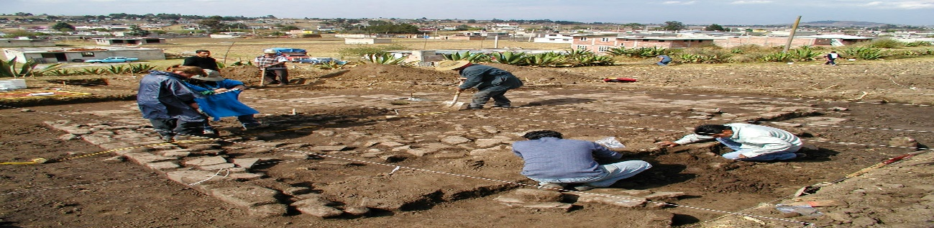

*Moles, Squirrels and Badgers Class*

*Spring Term 2024*

***English****Our class text for the Spring term will be Stig of the Dump. Written by the late Clive King, it relates the tale of a bored schoolboy, Barney, who meets a caveman called Stig living in an unofficial rubbish dump in a chalk pit. The two become unlikely friends and learn to communicate, as Barney helps Stig to refurbish his cave home with recycled rubbish from the dump. Alongside this we will also be using other texts, such as Stone Age Boy.*

*Reading for pleasure and enjoyment will lie at the heart of our English curriculum. Our new, class reading corners have become a big hit with our children. The children will be involved in guided reading, using a wide range of texts, linked to our topic. They will take part in group discussions and will be encouraged to share their own views and reading interests. Through discussion and questioning comprehension skills will be developed, enabling children to increase understanding and appreciation of literature.*

*Children will have the opportunity to find out more about a new poetry style this term. In their writing, they will be progressing their skills by writing instructions and adventure/mystery stories which we are sure the children will love.*

*Opportunities within all areas of the curriculum will be made available for children to develop their spoken language through discussion, drama, and presentations.*

***Archaeological Adventure!***

***More about our topic…***

*Our main topic for Spring term will be Archaeological adventure! We shall gain knowledge of the timeline and the order in which events and eras happened throughout history. The children will develop their understanding of history and how we have learnt so much.*

*They will be learning about the Stone, Bronze, and Iron Age throughout this topic. By the end of this unit, the children will know what it was like during these time periods. They will have a variety of experiences that will enhance their knowledge and understanding.*

*In addition to this, we will be using primary and secondary sources and discussing the validity of these. We will delve deeper into how archaeologists have discovered this information for us to learn. The children will learn about replicas and how they can be useful even if they didn’t come directly from that era.*

*This is an incredibly fascinating topic, and we aim to make it a memorable one! Through cross-curricular learning we will partake in some exciting activities. Make sure you continue to keep an eye on our web pages to see the fantastic learning taking place!*

***Maths -*** *will be taught as an individual subject and will continue to adhere to the curriculum objectives. Teaching will enable children to become fluent in arithmetic as well as being able to reason and problem solve. Our Maths lessons in the Spring term will focus on Multiplication and Division. This will be followed by Fractions and Decimals. Pupils will be extended at every opportunity to ensure their potential as mathematicians is achieved.*

***TTRockstars –*** *Every child should be completing TTRockstars at least 3 times a week. Year 4 should aim for 4 soundchecks weekly. Thank you.*

***Science****In Science this term, we will be initially looking at ‘Rocks and Fossils’. We will be learning about how the Earth naturally preserves sediments and artefacts – helping in the understanding of the world and the History that has come before.*