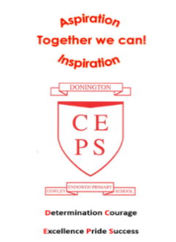
Life through a Lincolnshire Lens
Out of This World
Asian Discovery

Autumn Term 2023 | English  In English, we will be improving our grammar, language and ability to write for different purposes through our topic. Some of the exciting writing opportunities this term include writing film narratives, formal letters and performance poetry!  Reading for pleasure and enjoyment will lie at the heart of our English curriculum. Children will be involved in guided reading, using a wide range of texts, both linking to topic and our writing focuses. They will take part in group discussions and will be encouraged to share their own views and reading interests. Through discussion and questioning comprehension skills will be developed, enabling children to increase understanding and appreciation of literature.  Children are actively encouraged to continue reading at home and we can help children with book recommendations that they will enjoy. This year we have a large amount of new books and children will be taking regular trips to the new school library!  Opportunities within all areas of the curriculum will be made available for children to develop their spoken language through discussion, drama and presentations.
More about our topic…
This term in year 5 and 6 we will start the year by taking part in a local, geographical study. For the first two weeks children will be expanding their locational knowledge and researching our Lincolnshire surroundings making contrasts and comparing various areas.
After our geography focus we will be moving on to a new topic named ‘Out of this World.’ This is an incredibly exciting topic and we aim to make it a memorable one! We will be looking at the space race, the legacy of WW2 , the Cold War and the first moon landing. Through cross-curricular learning we will partake in some exciting activities and we are looking forward to this new adventure! Our first science topic will also look at space and earth science where we will be looking in depth at the various planets and key astronauts.
Pupils will extend their historical knowledge and will be able to build on their previous topics by using both primary and secondary sources and various means of research. Our key text will be ‘Wonder’ by RJ Palacio which is a fascinating class book that the children will all enjoy, which celebrates everybody’s differences.
Make sure you continue to keep an eye on our web page to see the fantastic learning taking place!

Maths
Maths will be taught as an individual subject and will continue to adhere to the curriculum objectives. Teaching will enable children to become fluent in arithmetic as well as being able to reason and problem solve. Maths lessons will cover all aspects including, understanding number, using all four operations, measurement, geometry and statistics. Pupils will be extended at every opportunity to ensure their potential as mathematicians is achieved. Next term we will be focussing on place value, the four operations and fractions.
Take home task to support work in school
To prepare for our new topic, it would be brilliant if the children could research a local Lincolnshire town or village to share with us in the first week back. This could be a seaside town, local town or where they live! Looking at the location, geography and any other interesting facts they can find.

